Deployment process -

CI/CD Pipelines we are using

Pipelines can be run automatically or manually. After run pipelines releases are created

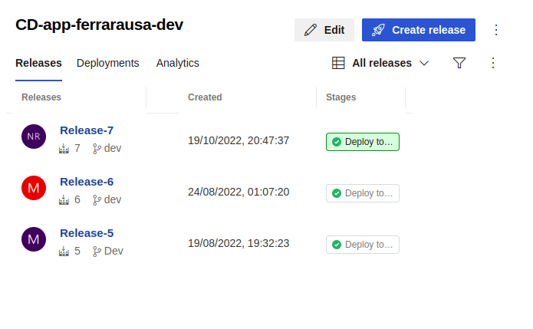

View Pipelines listing

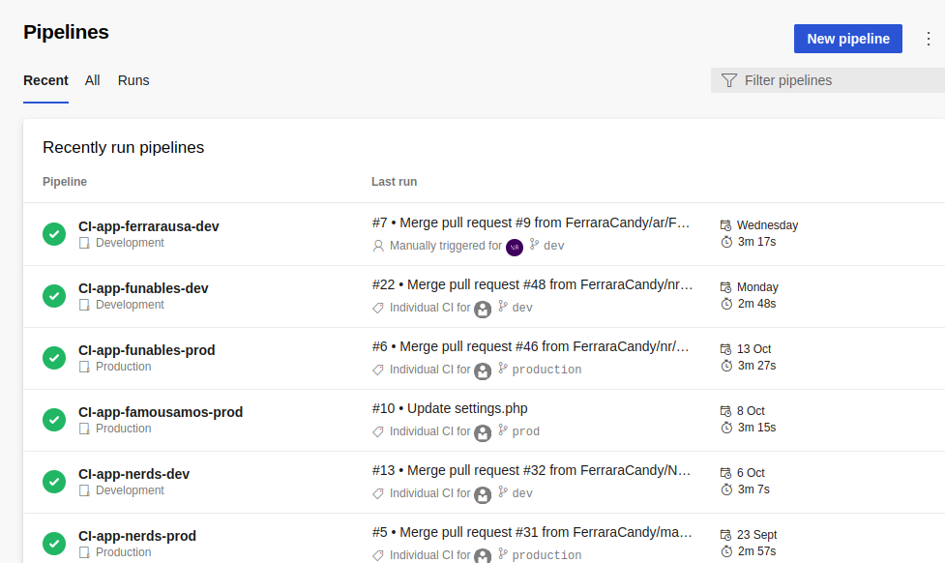

If pipeline is not triggered automatically due to any reason, we can run it manually by following steps:

1. Go to pipeline listing
2. Click on specific pipeline for which we need deployment for specific environment

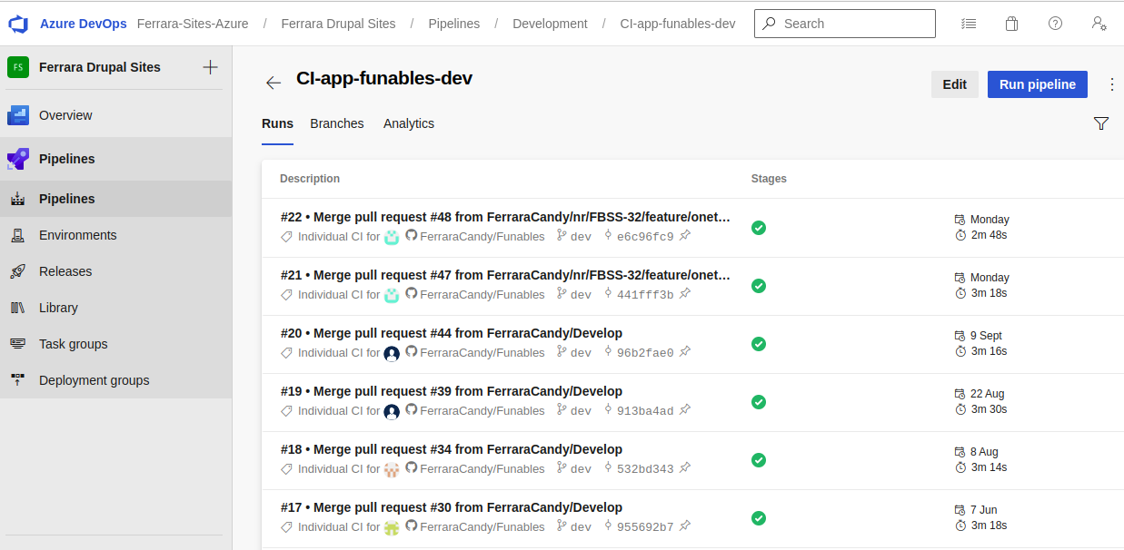

1. Click on ‘Run Pipeline’ button, popup will appear

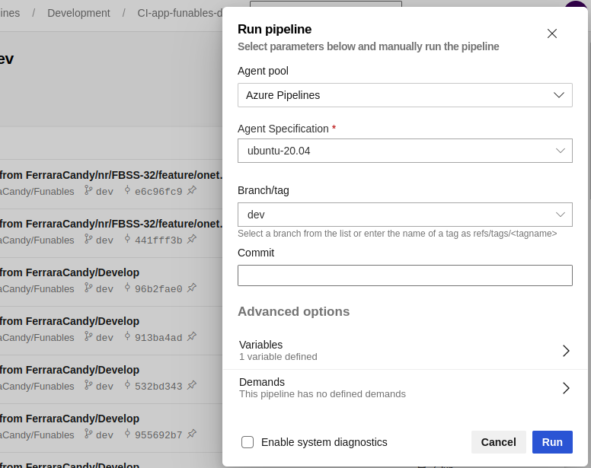

1. Click on run button, following screen will appear with running pipeline

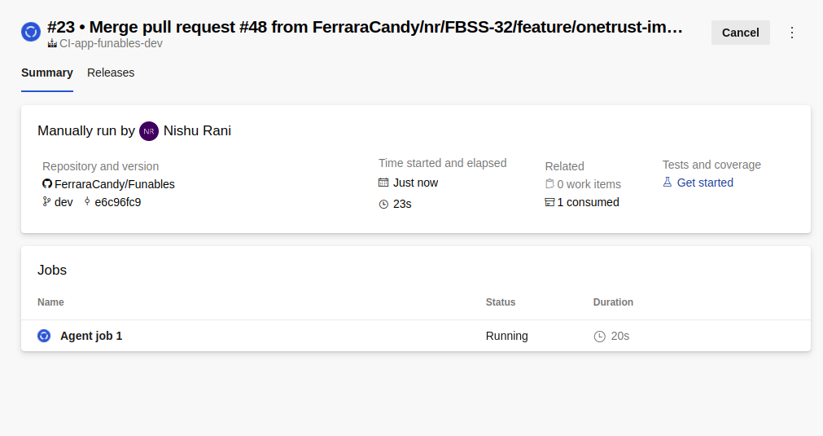

1. After the merged pull request we can check the changes using commit list

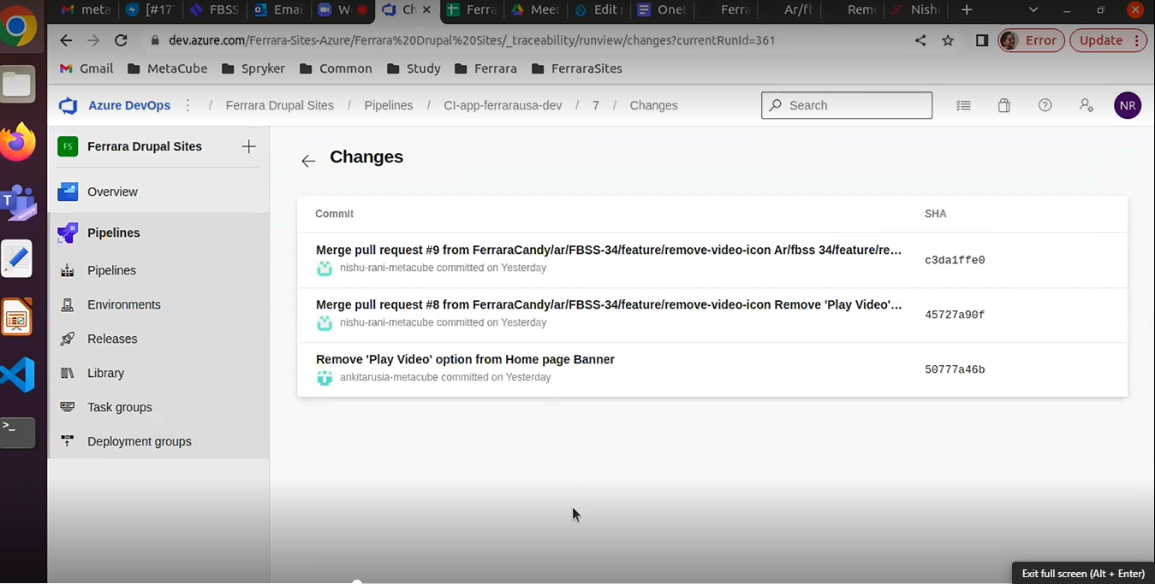

1. After the pipeline build is created successfully you can check your pipeline status using the option below in screen shots ‘Right now it is showing Running status in screen shot’. 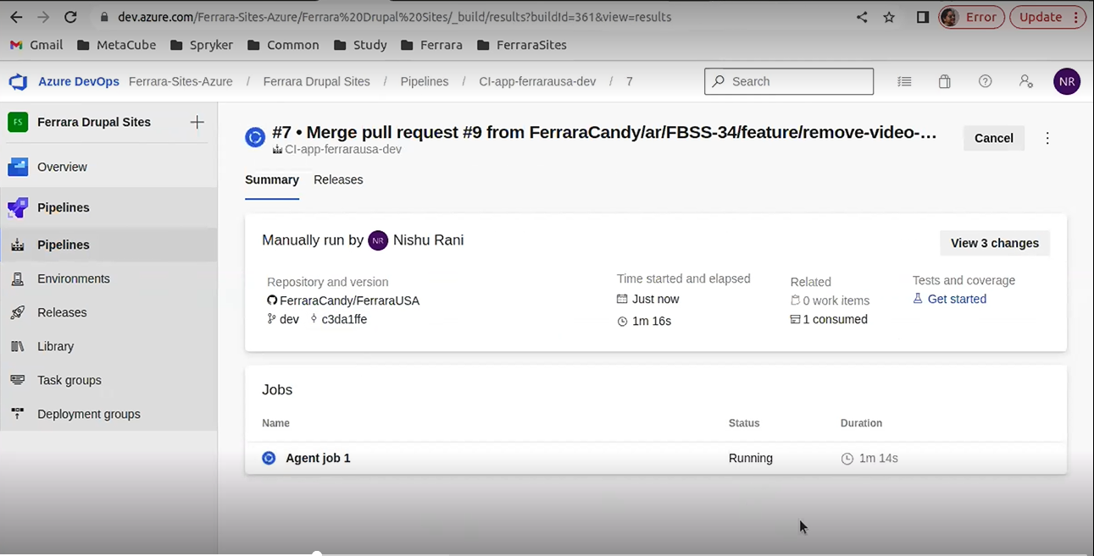
2. Once the pipeline build is complete then status will show completed. Once the pipeline build is completed and the composer installs all that data and deploy that on the actual environment so after build is done it will initial a release for that. We can see that in the below screenshots. After your release is created then your changes are reflected on the respective server.

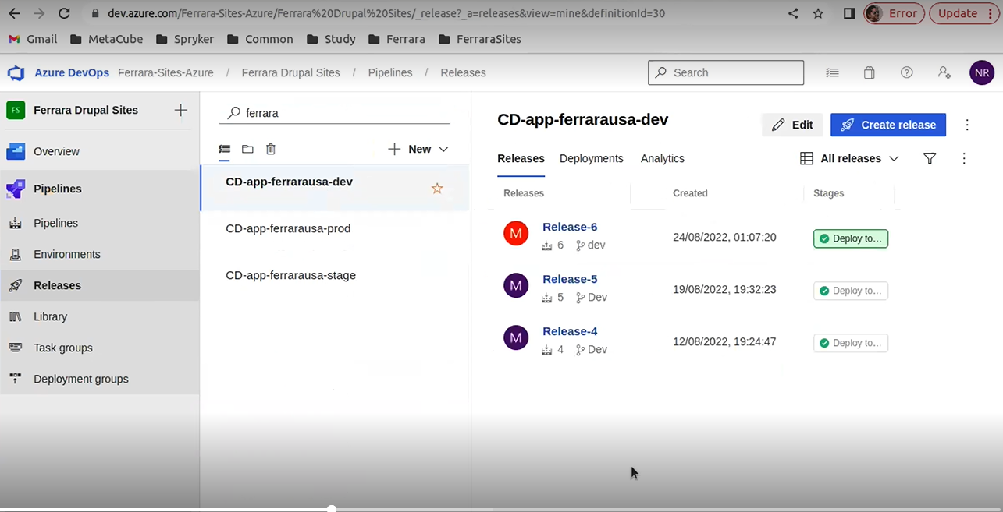

1. Sometimes release status showing up completed but changes are not reflected in the respective server for that we have to check release logs and find the issue which causes the problem of release success. Once we have the issue and after fixing that issue we will Re-Run release if you don’t get any issue then our changes will reflect on the server soon. Below step for more clarifications.

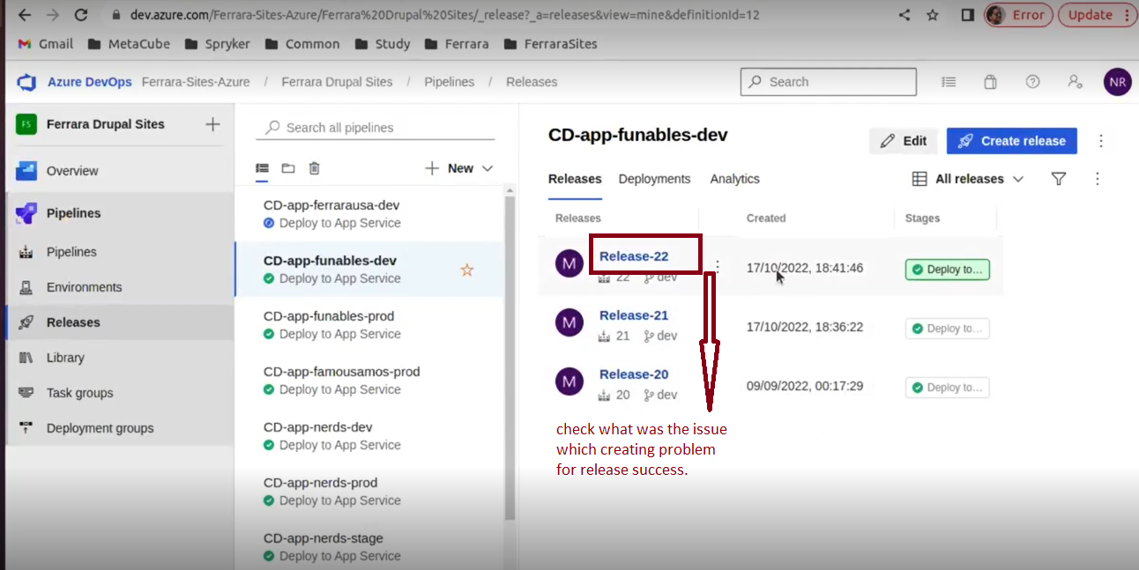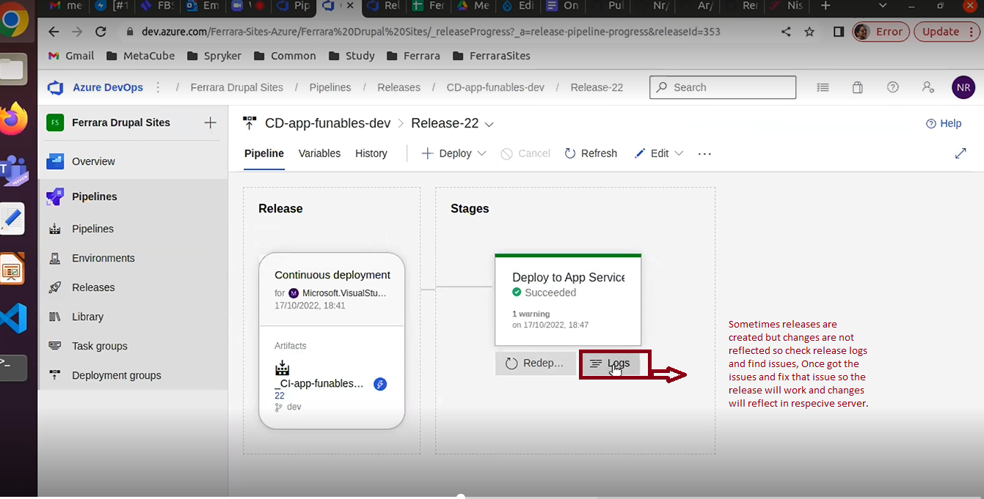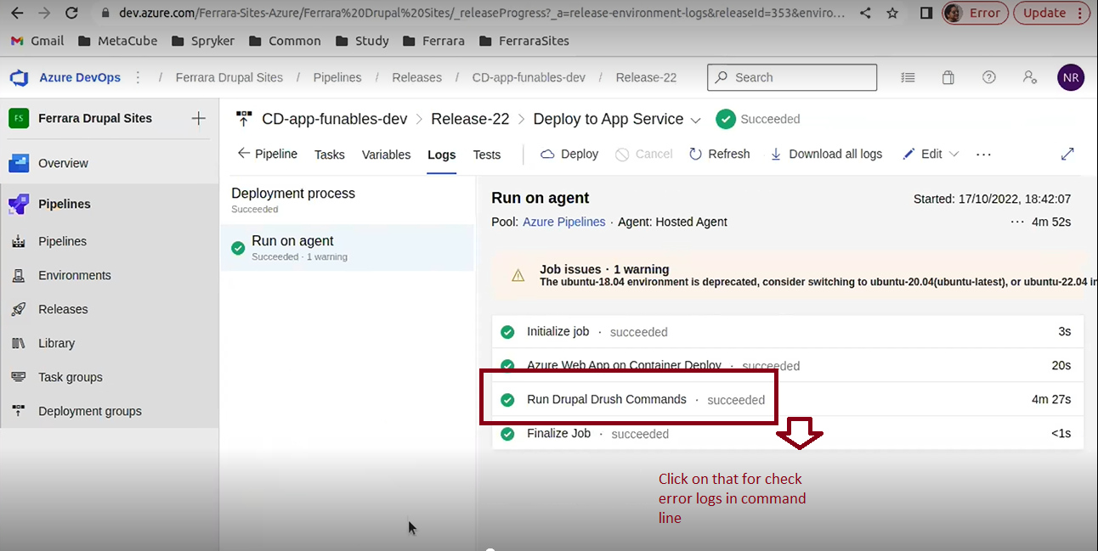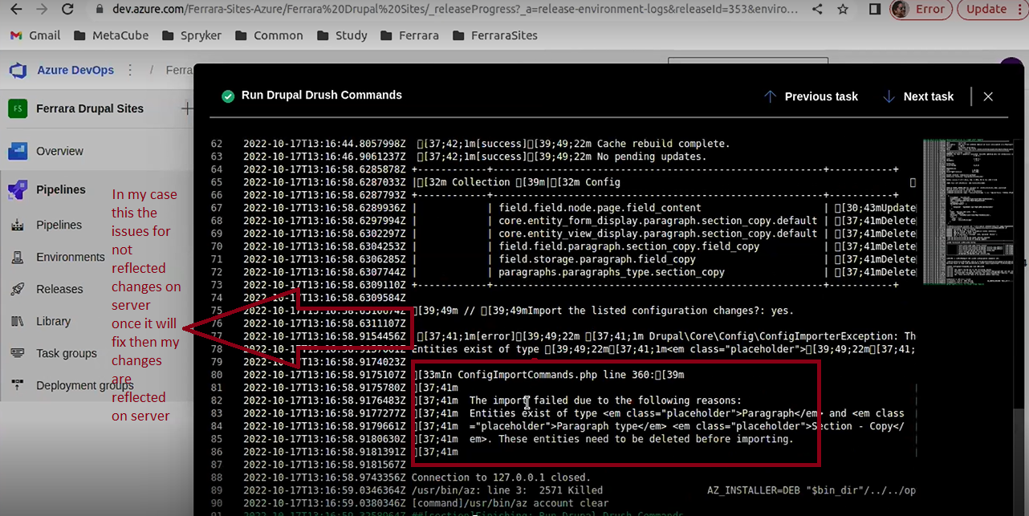

Note : Once resolved those types of issues then re-run the process and your changes will reflect soon on the respective server.

1. For manually run commands on the azure command line we have to follow below steps which are in screenshots. First we need to require azure access for that and once we have access to the azure and confluence then we have to follow the below steps.

* In the first Screenshot you can check your all server environments.
* In the Second Screenshot you can check your all app service, domains name , repo and develop CI/CD etc.
* In the third screenshots you can see all your project resources and you have selected one form these list for run commands.
* In the fourth step after selecting a resource you have to scroll down on the page and find the ssh option to go to the next step.
* In the fifth step we have to click the go link for the open command line for each project resource.
* In the last screen shot we can see the command line interface for executing our command related to the project.

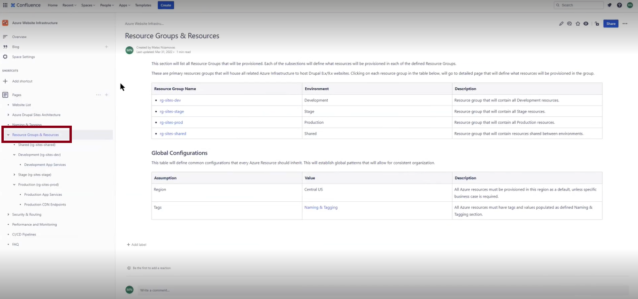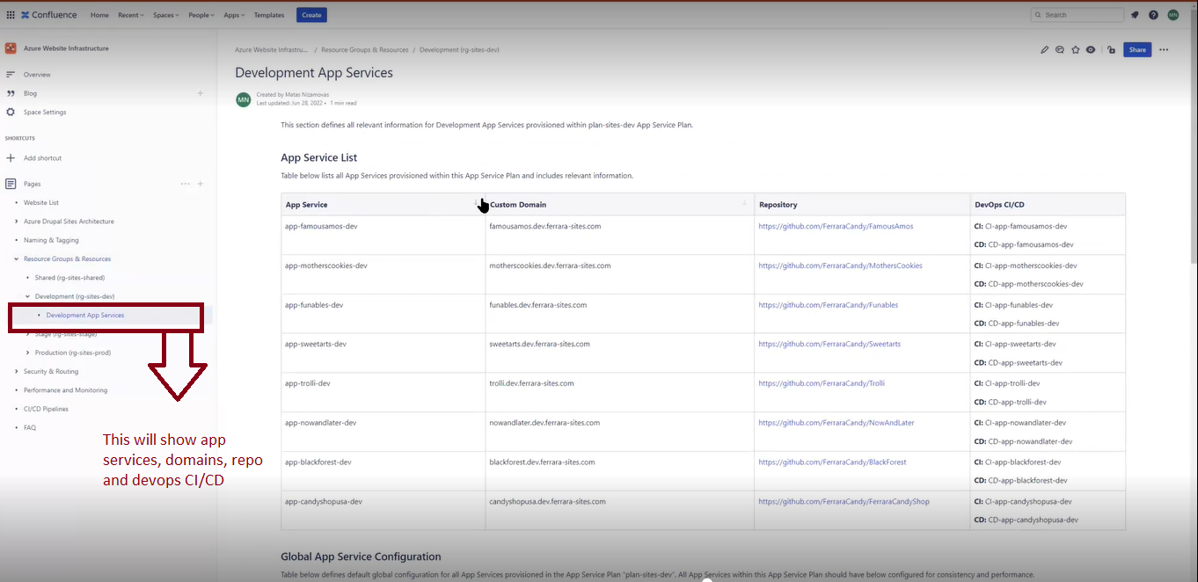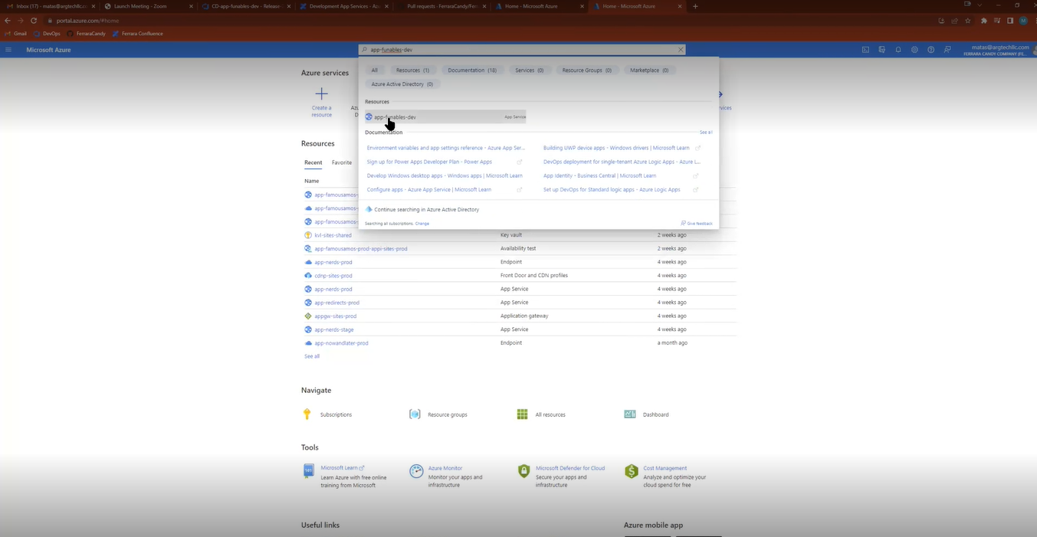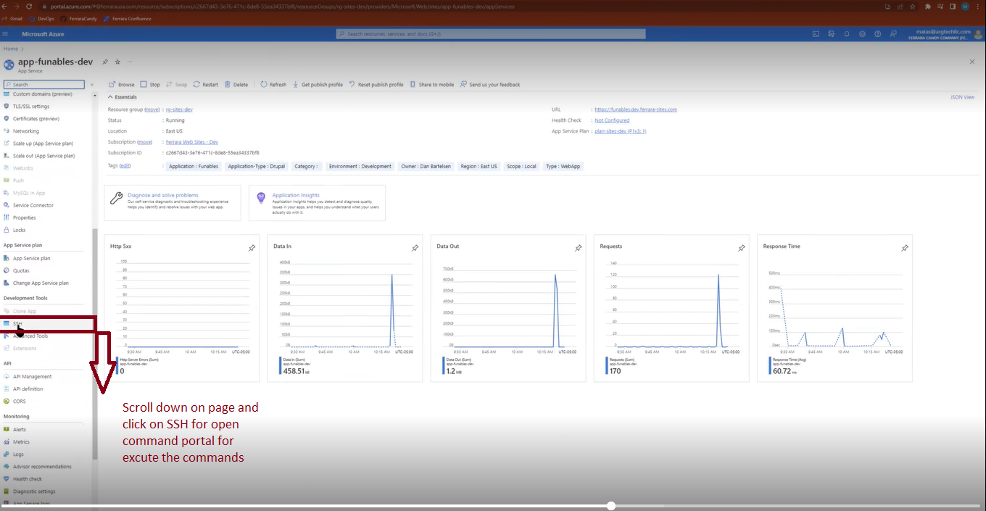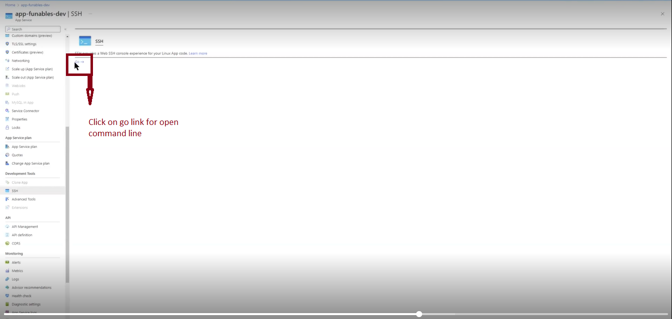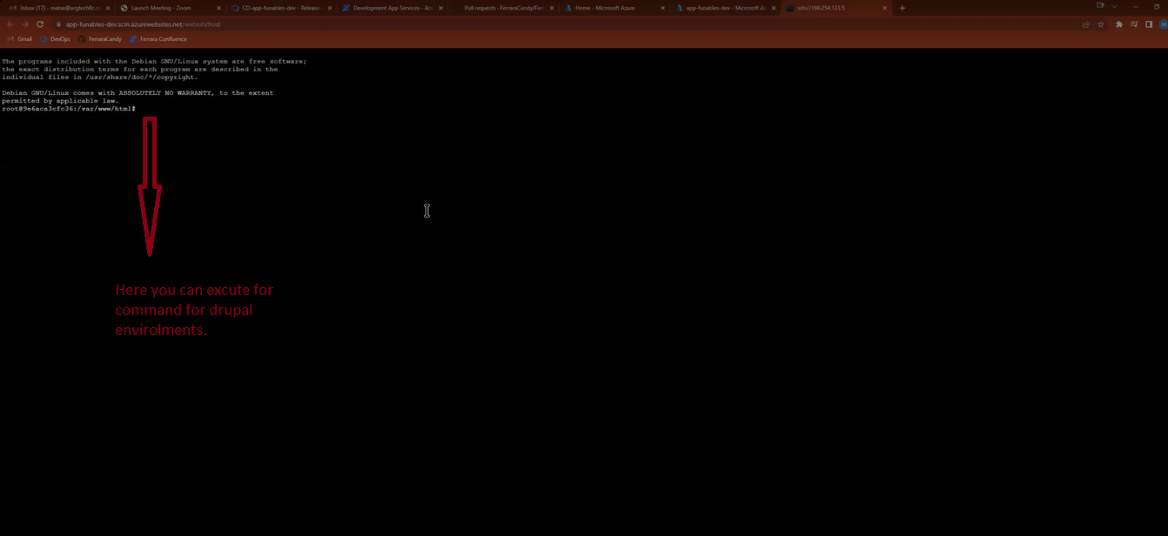

11. In some cases our code is deployed successfully but our site is not working due to some loophole or any error so we have to find out and fix the issue and redeploy it if it is not working then deploy the previous release. Like the screenshot below.

